Author guidelines
This document provides author guidelines for writing papers for the Sixth International Conference EEE 2017. Paper should be written in the same format in which this document is written. Please abide to the following instructions.

TITLE OF THE PAPER FONT CAMBRIA 16 PT BOLD, ITALIC, SPACING BEFORE 30 PT, AFTER 30 PT, CENTER, FIRST LINE 0
(Example of the style Heading 1)
First Author,
Second Author
TNR, lower case, 10 pt. Italic, Spacing before 6 pt., after 6 pt., Center, First line 0,
Each author in separate line.
(Example of the style Authors)

ABSTRACT (TITLES AND SUBTITLES STYLE)TNR 14 PT, BOLD ITALIC, ALIGN LEFT SPACING BEFORE 24 PT,AFTER 24 PT, CENTER, FIRST LINE 0
(Example of the style Heading 3)
Abstract should be written according to the following instructions: Abstract should not be longer than 300 words, font TNR 11 points, italic, justified. Below abstract write the key words and JEL classification, as it is shown in this example.
(Example of the style Body Text)
Key words (TNR 11 pt. Bold, Italic): key word 1, key word 2, key word 3, key word 4, key word 5 (max. 5 TNR 11 pt.)
JEL Classification (TNR 11 pt. Bold): two-digit number (e.g. M26) (TNR 11 pt.) http://www.aeaweb.org/jel/jel_class_system.php
(Example of the style Body Text)

INTRODUCTION
Monograph having an international significance (M12) is a publication dealing with thematics that have an international importance and is published in one of the world languages. Publisher of such monographs should be a well-known and renowned international or domestic (for social sciences) publishing house with a long tradition in publishing scientific papers. It needs to have at least seven auto-citations, in case of social and humanistic sciences, category either M10 or M20 or M40.
Chapter in a publication M12 = M14 counts for 5 points.
The number of self-citations in this publication is equal to the number of citations for the monograph in question divided by three (rounded to the lower digit).
Thematic collection is a joint scientific publication that in a comprehensive and systematic way studies a certain area of scientific problematics and that is issued by a scientific institution, scientific association in the field of culture or an eminent publisher. Thematic collection contains professionally reviewed original scientific papers, inlcuding the final report texts presented at thematic scientific gatherings. Periodic publications can also have the characteristics of thematic collections if they concern the appropriate theme in their entirety or in separate parts. Thematic collection of an international significance is a scientific publication with an international participation.
Full authorship for the paper in a thematic collection is approved if there are no more than 2 authors. If there are three or more authors, the paper is evaluated according to the rules for co-authoring papers.
Papers in monographic publications and thematic collections from this category need to be reviewed by two competent reviewers.
In order to be evaluated in this category, author’s contribution to the monograph or thematic collection must not be less than one sheet of text (16 pages), (one page = 1,800 characters) (Rule Book of the Quantitative Evaluation, 2017, attachment 2, pp. 2-5).
(Example of the style Body Text)

TECHNICAL DEMANDS
All papers should be written in English. (Times New Roman – TNR 11 pt. normal).All papers should be typed in Latin in MS Word. Minimum of the characters in the paper is 28800 characters. All pages should be in B5 (ISO) format (20.1 cm x 27.6 cm). All margins (top, bottom, left and right) should be 2.3 cm. Text should be written in one column (not two or more) and in font Times New Roman, including the titles of pictures and tables, with single spacing [TNR, 11 point, normal, justified alignment, first line – 0.7 cm, spacing – before = 3pt, after = 3pt, line spacing – single, upper and lower case).The beginning of the paragraph should be written without using Tab or space.
There cannot be more than two authors in one paper. One author can send a maximum of two papers for the conference and one for the round table.
Papers should be submitted via conference website: www.eee-conference.com in the section for paper submission, no later than the 10th of August 2017.
In order for the paper to be published in the Conference Proceedings, it is necessary to be written according to these instructions. Information on paper acceptance will be sent no later than the 1st of September 2017. Final program and the schedule of the presentations will be known no later than the 10th of October 2017.
(Example of the style Body text)
Please note the additional instructions at the end of this document.

TABLES
All tables should be numbered starting with number 1. Title of the table should be written in TNR 11 pt. Italic, Spacing after 12 pt., after 12 pt., keep with next, above the table and centered. Tables should look like the following one:
Table 1. Title of the table
(Example of Table/Figure/Picture)
Column 1 | Column 2 | Column 3
Row 1 | Row 1 | Row 1
Row 2 | Row 2 | Row 2
Row 3 | Row 3 | Row 3
Source: Primorac, 2005, pp. 20-23
(Example of the style Izvor)
Please do not bold the title and the number of the table.

PICTURES
All pictures should be numbered starting with number 1. The title of the picture should be written in TNR 11 pt., below the picture and centred. Please do not insert the text boxes above or below the picture. The picture should look like the following one:
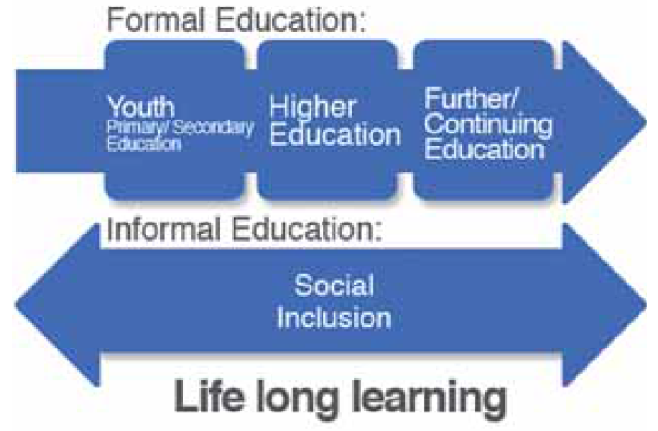
Picture 1. Title of the picture
(Example of Table/Figure/Picture)
Source: Primorac, 2005, pp. 20-23
(Example of the style Izvor)
Please do not bold the title and the number of the picture.

ENUMERATING IN THE TEXT
If you are enumerating in the text, please follow these instructions:
- Using bullets
- Move the text left 0.7 cm, hanging 0.3 cm, spacing before 6 pt, after 6 pt, Don’t add space between paragraphs of the same style.
- Use font Times New Roman (TNR) 11.
(Example of the style Lista Bullet)
- Using numbers
- Turn off auto numbering, separate the number from the text by pressing TAB once, move the text left 0.7 cm, hanging 0.55 cm, spacing before 6 pt, after 6 pt, Don’t add space between paragraphs of the same style.
- Use font Times New Roman (TNR) 11
(Example of the style List Paragraph)

EQUATIONS
Equations should be 5mm from the left margin, and the ordinal number of the equation should have right alignment. Equations should be written in Times New Roman (TNR) 11 pt., and the ordinal numbers should be written in parenthesis TNR 11 pt, as it is shown. Use Microsoft Equation if possible.
$R_{a}=\text{ 0,65}⋅R_{\text{max}}^{0,9}$ (1)

RECOMMENDATIONS CONCERNING PAGE NUMBERING, FOOTNOTES, HEADERS ETC.
Please do not number the pages and do not use headers and footnotes.

CONCLUSION
Papers that do not keep up with these instructions, or that are submitted after the deadline, will not be printed in the Conference Proceedings. If you need any further information feel free to contact us via e-mail conference@vspep.edu.rs.

REFERENCES
References in the text is stated in Harvard style (http://www.sciencebg.net/download/harvard-style-en.pdf). The list of references should be given at the very end of the paper, stating only titles that were quoted in the paper.
Quotations in the text should be written according to the following instructions: Author’s last name, year of publication, page/s. Example: (Primorac, 2005, pp. 20-23).
References should be written according to the following instructions:
[1] For books: author’s last name, first letter of the author’s or editor’s name, (year of publication), title of the book, place of publication: publisher. Example: Primorac, Z. (2005), Uvod u filozofiju. Novi Sad: Fram-Ziral.
[2] For papers in conference proceedings: author’s last name, first letter of the author’s name, (year of publication), title of the paper, last name, first letter of the editor’s name (ed), title of the conference proceeding. Place of publication: publisher, pages. Example: Paar, V. (2011), O komplementarnosti nauke i obrazovanja, u Primorac, Z. (ed), Savremena. Belgrade: Faculty of Political Sciences University in Sarajevo, pp. 19-35.
[3] For papers in magazines: author’s last name, first letter of the author’s name (year of publication), title of the paper, name of the magazine, issue number, page. Example: Bevanda, M. (2007), Školstvo između reformiranja i deformiranja. Savremena pitanja, 3(2): 9-20.
[4] http://www.ekoplan.gov.rs (date)
Do not use automatic numeration, ordinal number should be separated from the text by using TAB. Font TNR 11, Spacing before 6 pt., after 6 pt., turn on the option Don’t add space between paragraphs of the same style, hanging 0.62cm, tab stop 0.62 cm
(Example of the style List Literatura)

ADDITIONAL INSTRUCTIONS
Dear associates,

In writing this document the following styles were used:
- Heading 1 – The title of the paper
- Heading 3 – All other titles and subtitles in the paper
- Authors – names of the authors
- Body Text – paragraphs
- Tabela/Figura/Slika – titles of tables, figures and pictures
- Izvor – sources of the tables, figures and pictures
- Lista Bullet – enumerating using bullets
- List Paragraph – enumerating using numbers
- List Literatura – enumerating the literature

While arranging your paper we recommend you to use one of the following three procedures:
- First option is to use the styles that were created in this document by using the option manage styles import/export and import the styles in your paper and allocate the appropriate styles to the appropriate parts of your paper (import is done from your paper)
- Second option is to save these instructions as a new document then erase the text and paste your paper, and then apply the styles that are already created here.
- Third option is to manually create and adjust the styles that already exist in your paper based on the data given in this document.

Title, Institution, City, State, e-mail (TNR 9 pt.)
Title, Institution, City, State, e-mail (TNR 9 pt.)

